Peripherals and Power Supply

Assignment 1 DAY1

TASK1.Create a table listing 3 types of printers, 2 types of scanners, and 2 types of webcams, and for each, write one real-life use case (for example: 'Inkjet printer – printing college assignments').
Device Type | Example | Real-Life Use Case
Printer | Inkjet Printer | Printing college assignments and project reports at home.
Printer | Laser Printer | Printing large batches of office documents quickly.
Printer | Dot Matrix Printer | Used in the railways for printing tickets.
Scanner | Flatbed Scanner | Scanning pages from textbooks to save as PDF files.
Scanner | Handheld Scanner | Scanning sections of books in the library without moving them.
Webcam | Built-in Laptop Webcam | Attending online classes and video meetings.
Webcam | External USB Webcam | Recording video presentations for college projects.

TASK2. Draw a labeled diagram showing how a typical home printer connects to a laptop or PC, including the connection interface used (USB, Wi-Fi, or Bluetooth).
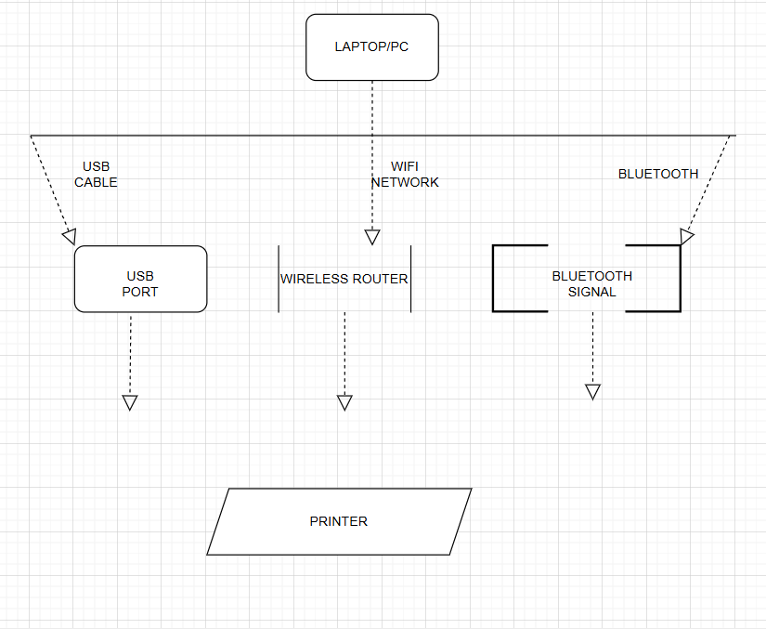

TASK3. List three different connection interfaces (such as USB, Wi-Fi, Bluetooth) used by peripherals like printers, scanners, and webcams, and for each, name one advantage and one disadvantage. <br><br><em><strong>Hint:</strong> Think about speed, convenience, and compatibility. </em>
Connection Interface | Advantage | Disadvantage
USB (Universal Serial Bus) | Fast and reliable connection; easy to set up with a simple cable. | Requires a physical cable and free USB port on the computer.
Wi-Fi (Wireless Network) | Very convenient; allows multiple devices to share one printer or scanner without cables. | Can be slower or unreliable if the Wi-Fi signal is weak or crowded.
Bluetooth | Good for short-range wireless connections; no cables needed and easy pairing for small devices. | Shorter range than Wi-Fi and often slower data transfer speed.

TASK4. Pick any one device you use at home or college (printer, scanner, or webcam). Write step-by-step instructions for how you would connect it to your computer, including what cable or wireless method you would use and any setup steps required.
STEPS:-
Step 1: Unpack and Prepare the Printer
- Remove all packaging materials and protective tapes.
- Place the printer on a stable surface near the computer.
Step 2: Connect the Power Cable
- Plug the printer's power cable into an electrical outlet.
- Turn on the printer using the power button.
Step 3: Install Ink/Toner and Load Paper
- Insert the ink cartridges or toner cartridge according to the manufacturer's instructions.
- Load paper into the paper tray.
Step 4: Connect the USB Cable
- Plug one end of the USB cable into the printer's USB port.
- Plug the other end into an available USB port on the computer.
Step 5: Install Printer Drivers
- The computer may automatically detect the printer and install the required drivers.
- If not, install the drivers from the printer's installation CD or download them from the manufacturer's website.
Step 6: Add the Printer
- Open Settings > Printers & Scanners on the computer.
- Check that the printer appears in the list of available printers.
Step 7: Print a Test Page
- Open a document.
- Select File > Print.
- Choose the connected printer and click Print.
- Verify that the test page prints correctly.

